**Generalized Linear Models**

**Name: Rachit Shah (rshah25)**

**Problem 1 (25 points: 5 points each question): Building and analyzing the logistic regression model**

For the problem below, build the logistic regression model (fit.all) using all the predictors and answer the following questions by including the corresponding R code and showing all the required mathematical derivations used to answer these questions:

1. **Let $X_{h}$ be the predictor with the highest estimate (in terms of its absolute value) for its regression coefficient. Build a single predictor logistic regression model (*fit.single*) using $X_{h}$ as the predictor. Write the equations relating the dependent variable (Response) to the explanatory variable in terms of:**

ANS:

From the summary of fit.all, we can see that the predictor with highest estimate is $X_{h}=currency_GBP$ with an estimate of 2.014

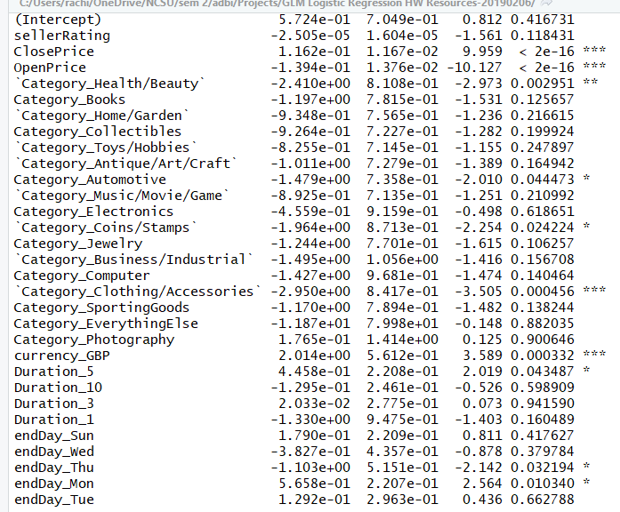

1. Probabilities:
$$Prob\left(Y=Yes \right| X_{h}=x)=\frac{1}{1+e^{-\left(0.07930+0.69140*currencyGBP\right)}}$$

2. Odds:

$Odds=\frac{p}{1-p}=\frac{\frac{1}{1+e^{-\left(0.07930+0.69140*currencyGBP\right)}}}{1-\frac{1}{1+e^{-\left(0.07930+0.69140*currencyGBP\right)}}}=e^{\left(0.07930+0.69140*currencyGBP\right)}$

1. Logit
$$Logit=\log\left(odds\right)=\log\left(e^{\left(0.07930+0.69140*currencyGBP\right)}\right)=0.07930+0.69140*currencyGBP$$

2. **Write the estimated equation for the *fit.all* model in all three formats (if the number of predictors is more than four, then include only those four predictors whose absolute value estimates are the highest):**

**ANS:**

The 4 predictors with the highest estimates are: currencyGBP, endDayMon, Duration5 and endDaySun.

* 1. The logit as a function of the predictors.
 $$Logit=0.5724+2.0141*currencyGBP+0.5658*endDayMon+0.4458*Duration5+0.179*endDaySun$$

 2. The odds as a function of the predictors.
 $$Odds=e^{logit}=e^{0.5724+2.0141*currencyGBP+0.5658*endDayMon+0.4458*Duration5+0.179*endDaySun}$$

 3. The probability as a function of the predictors

$$Prob=\frac{odds}{1+odds}=\frac{e^{logit}}{1+e^{logit}}=\frac{1}{1+e^{-logit}}=\frac{1}{1+e^{-\left(0.5724+2.0141*currencyGBP+0.5658*endDayMon+0.4458*Duration5+0.179*endDaySun\right)}}$$

1. **Let $X_{h}$ be the predictor with the highest estimate (in terms of its absolute value) for its regression coefficient in the *fit.all*. Compute the odds ratio that estimated a single unit increase in $X_{h}$, holding the other predictors constant. For example, if $X_{h}=1 then$:**

$$\frac{odds(X_{1}+1,X_{2},…,X_{q})}{odds(X_{1},X_{2},…,X_{q})}=$$

**Provide the interpretation for this regression coefficient. If it were a linear regression model, how would the interpretation change for a single unit increase in $X_{h}$.**

**ANS:**

Here, $X_{h}=currencyGBP$ and the rest of the predictors $X_{2},X_{3},…X_{q}$ are constant. Hence,

$$\frac{odds(X_{1}+1,X_{2},…,X_{q})}{odds(X_{1},X_{2},…,X_{q})}=\frac{e^{Int+coef*\left(X_{h}+1\right)}}{e^{Int+coef*X_{h}}}=e^{Int-Int+coef*X_{h}-coef*X_{h}+coef}=e^{coef}$$

Since the estimate for currencyGBP is 2.014, $e^{coef}=e^{2.014}=7.493$

This means that for a unit increase of currencyGBP, the response variable will change 7.493 times for logistic regression. For 10 times increase in currencyGBP will cause 7.493^10 increase in response variable.

However, for linear regression, the change would be proportional to 2.014 and not its exponential.

1. **Build a reduced logistic regression model (*fit.reduced*) using only the predictors that are statistically significant. Assess if the reduced model is equivalent to the full model. Justify your answer.**

**ANS:**

The statistically significant predictors which we can ascertain from fit.all are: ClosePrice, OpenPrice, `Category_Health/Beauty`, Category_Automotive, `Category_Coins/Stamps`, `Category_Clothing/Accessories`, currency_GBP, Duration_5, endDay_Thu and endDay_Mon.

After fitting this reduced model and performing chi-square anova test we can find whether they are equivalent or not. From the result of the test, the p-value is 0.3162 which states that the difference is not significant and hence they are equivalent. Hence, we should choose the simpler model.

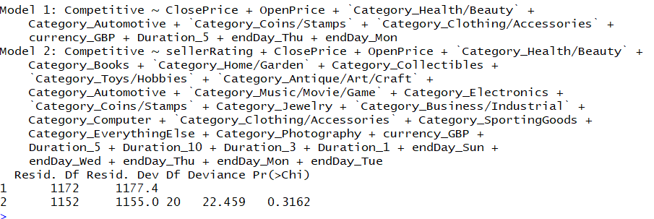

1. **Compute the dispersion of your model and run the dispersion diagnostic test. If the constructed model is overdispersed, then discuss the ways to deal with the issue.**

**ANS:**

The dispersion of the model can be calculated by the formula:

$$Dispersion ∅=\frac{Residual Deviance}{ Degrees of Freedom}=\frac{1155}{1152}=1.00464≈1$$

Hence, the dispersion is not too great then 1. Also, the dispersion diagnostic test in qcc package returns a p-value of 1 signifying that the model is not overdispersed.

If the test had resulted positive and there was overdispersion in our model, then we would have to refit our model with quasi-binomial distribution instead of binomial.

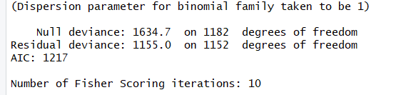

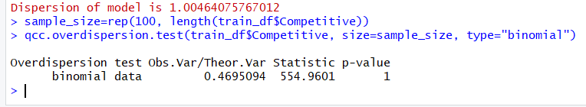

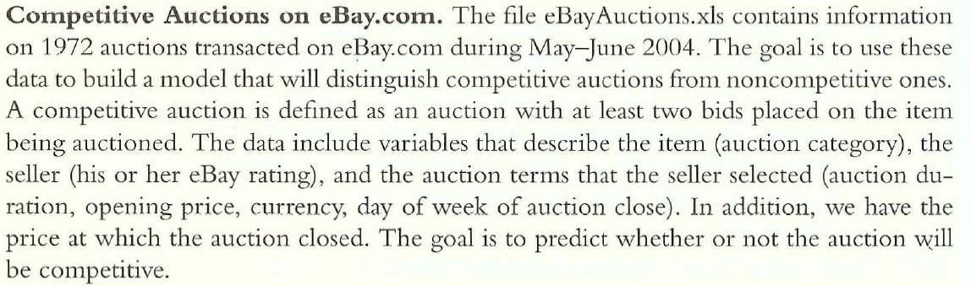

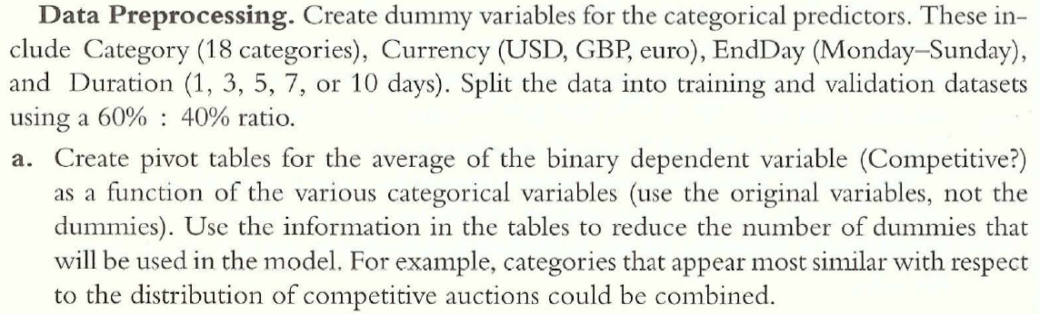

See R code